**Dubai**

5* Jumeirah Beach From £639 pp 5*Atlantis The Palm From £559 pp 5*Anantara The Palm From £529 pp

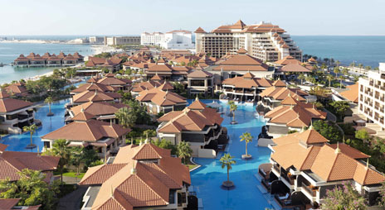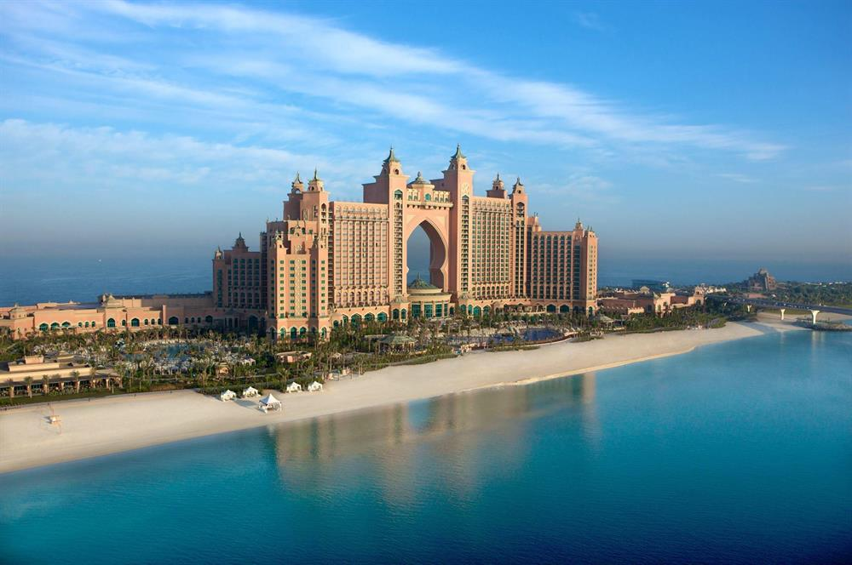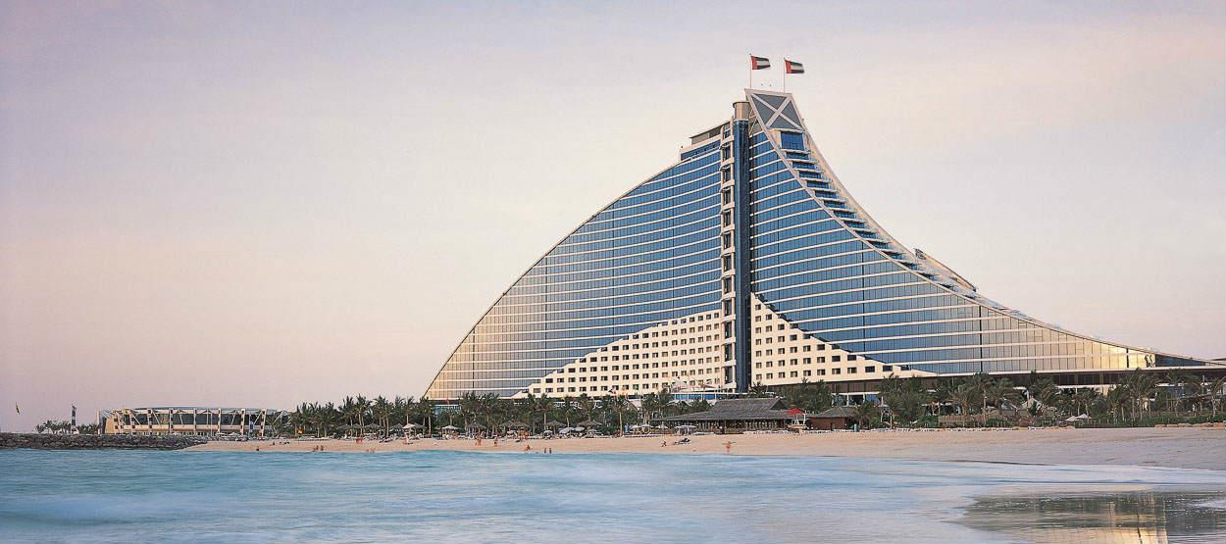

5*Ritz CarltonFrom £629 pp 5* Sofitel The Palm From £519 pp 5*One & Only DubaiFrom £879 pp



